Acclaimed Poet Publishes Fourth Poetry Collection with Salmon Poetry, a Distinguished Poetry Press in Ireland

Stephen Roger Powers, widely published poet, announces the February 26, 2024, publication by Salmon Poetry of his fourth poetry collection, Hail My Attention Kindly.

Book description from the back cover:

Hail My Attention Kindly, the fourth collection of lyric and narrative poetry by Stephen Roger Powers, is a sweeping and bewitching tour through India, Ireland, Jekyll Island, New York City, London, Berlin, Hawaii, the Northwoods of Wisconsin, and, of course, the musical and sparkly world of Dolly Parton. Powers’ voice is both droll and pensive as it explores wanderlust and the majesty and power of the natural world. In their twists and turns of language and imagery, these poems also delve into disability, loss, and resistance to nationalism and dogma. Like one of Dollywood’s award-winning roller coasters, the poetry in Hail My Attention Kindly leaves the reader jolted, breathless, windswept, and wanting to go around again.
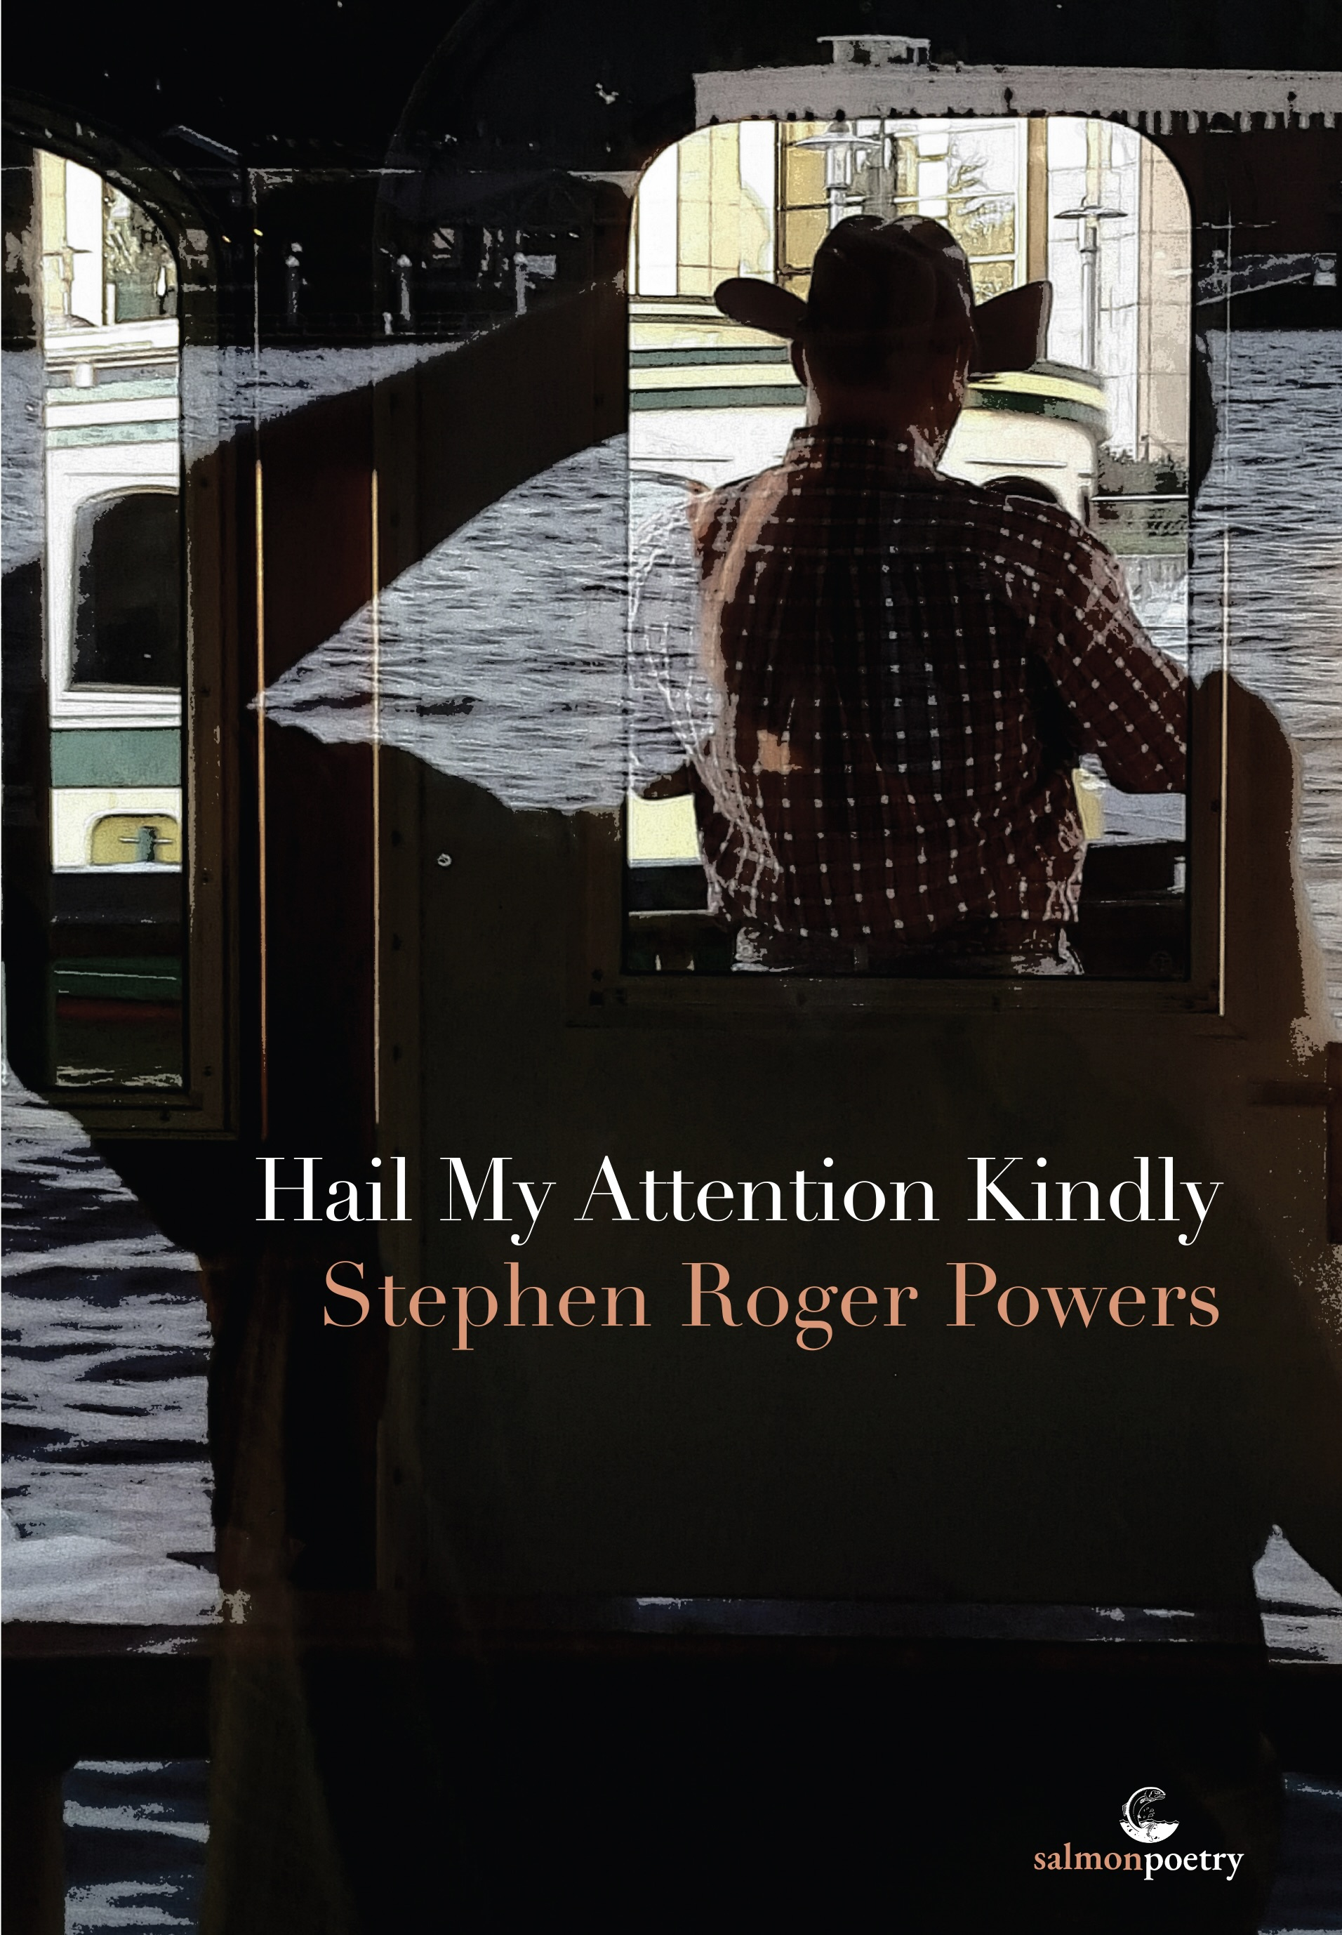
ISBN 978-1-915022-49-3
Cover photograph by Michael Sergi, MD
Author photograph by Susan Powers

Praise for Previous Publications by Stephen Roger Powers

“…funny and celebratory.”

— Matthew Gilbert, The Boston Globe

“…distinctive, flavor-filled, driven work.”

— Russell Gardner Jr., Verse Wisconsin

“Aiming to tell an offbeat and original story, [Powers] brings readers a unique brand of poetry that hasn’t been seen much before. The Follower's Tale is a choice pick for poetry lovers, highly recommended.”

— Midwest Book Review

“The poems do not sound like they are conventional poetry.”

— Books Ireland

“Not only does Powers entrance us with his humorous word-pictures, but the imagery and words he uses make us feel like he himself is writing songs to the reader, creating rhythms and roller-coasters of surprising word phrases that continue to draw us in line by line…”

— Sandra Cohen Margulius, the museum of americana

“Powers’ poems are not an escape from reality; rather, they detail the sad ache of nostalgia and the beauty of somehow knowing, even in one’s golden years, that the tarnish is inevitable and possibly already there.”

— Chase Dimock, As It Ought to Be Magazine

“Powers’ poems are intelligent and good-hearted. They’re funny, alive, and also capable of profound anger or quiet meditation.”

— Shawn Delgado, storySouth

Contact

www.stephenrogerpowers.com
stephen@stephenrogerpowers.com

www.salmonpoetry.com

Born and raised in Wisconsin, Stephen Roger Powers has coped with profound hearing loss most of his life. He was a delivery driver and a stand-up comedian while working on his PhD in English, and he has lost count of how many times he has seen Dolly Parton at Dollywood and in concert. Powers has published four poetry collections with Salmon Poetry; his first includes an endorsement from Dolly Parton on the back cover. His collection of short stories, Highway Speed, was published by Closet Skeleton Press. His writing has appeared in over 100 journals and anthologies, including 32 Poems, The Comstock Review, Copper Nickel, Natural Bridge, Shenandoah, and Let Me Say This: A Dolly Parton Poetry Anthology.

Salmon Poetry, taking its name from the Salmon of Knowledge in Celtic mythology, was established in 1981 as an alternative voice in Irish literature. By specializing in the promotion of new poets, particularly women poets, Salmon has enriched Irish literary publishing. In recent years Salmon has developed a cross-cultural, international literary dialogue and has the endorsement of Michael D. Higgins, the current president of Ireland. Salmon places a strong emphasis on the design of its books and has been consistently praised for the quality of its productions. Their books are distributed in the USA by Casemate.

